Name : Romaysaa Mohamed Saad

B.N / 325

Date / 6/6/2021

Topic : Artificial intelligence.

Applaction brief : Artificial intelligence, defined as intelligence exhibited by machines, has many applications in today's society. More specifically, it is Weak AI, the form of AI where programs are developed to perform specific tasks, that is being utilized for a wide range of activities including medical diagnosis, electronic trading platforms, robot control, and remote sensing. AI has been used to develop and advance numerous fields and industries, including finance, healthcare, education, transportation, and more.

Screenshots :

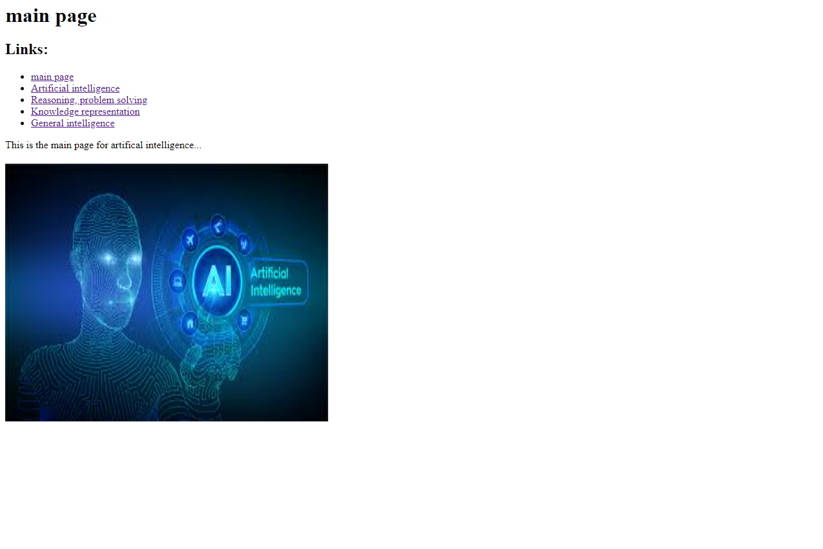

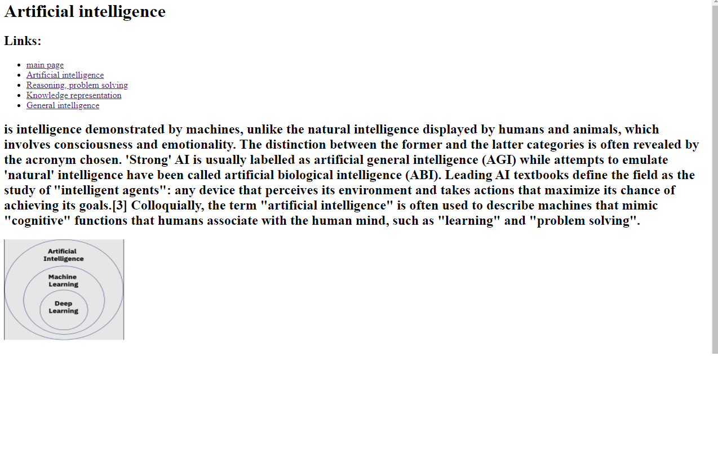

Source code :

